CeEst ERP
FACILITIES MANAGEMENT ENHANCEMENT PACK
Developer Requirements, FM Strategy, ERP Cards, Reports & Dashboards
Manage → Monitor → Measure → Advise → Improve
Prepared for Center Estates (CeEst)
August 2026

1. Purpose of this Developer Pack
This document converts the CeEst facilities management strategy into practical ERP requirements. It is intended to guide the ERP developer in improving the existing CeEst platform so that the FM module does not merely record maintenance activities, but manages property performance, asset lifecycle, service quality, cost, risk, compliance and strategic client advice.

Developer principle
Every transaction should be traceable from property → building/area → asset/service → request/work order → provider → cost → evidence → KPI → report. The system should use one source of truth and automatically turn operational data into management information.
Design principle | ERP implication
Single property hierarchy | Property → Building → Floor → Area/Unit → Asset
Evidence first | Photos, plans, certificates, quotations, invoices and approvals attached to records
Automatic control | Due dates, SLAs, budgets, expiries, thresholds and escalations generate flags
Performance by design | Every service has a target, actual result and responsible owner
Client-ready outputs | Reports and dashboards generated directly from live ERP data

2. CeEst FM Strategy Pitch to Clients
CeEst should position FM as a strategic performance service. The client should understand that CeEst does not only repair faults or coordinate contractors. CeEst manages the facility as a business asset and continuously improves its cost, reliability, compliance, service quality and lifecycle performance.
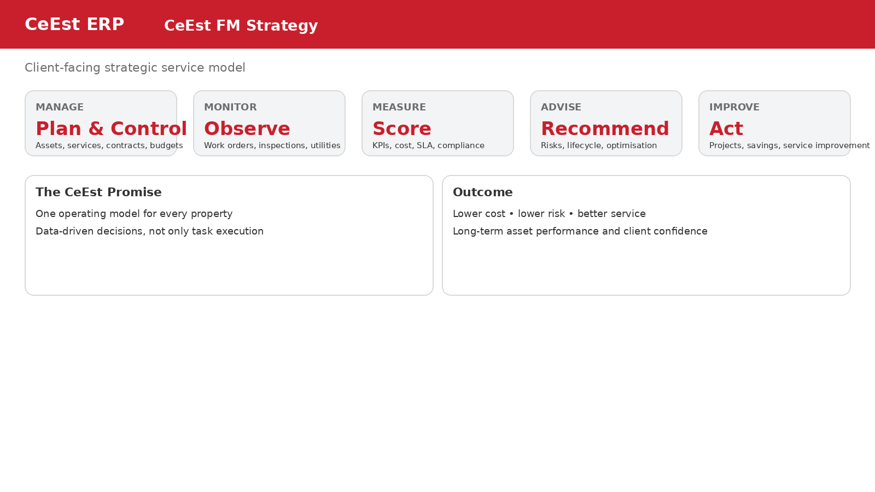

The five-step CeEst proposition
Stage | What CeEst does | Client outcome
Manage | Plan services, assets, contracts, budgets, people and providers. | Control and accountability
Monitor | Track work orders, inspections, utilities, assets, SLAs and compliance. | Early visibility of problems
Measure | Convert actual performance into KPIs, cost reports and scorecards. | Evidence-based decisions
Advise | Identify risks, savings, lifecycle requirements and service improvements. | Better strategic decisions
Improve | Implement corrective actions, projects, renewals and optimisation programmes. | Continuous improvement
Suggested client pitch: “CeEst manages the performance of your facilities—not just the tasks. We manage, monitor, measure, advise and improve the property environment so that it supports your organisation's objectives.”

3. Building Information Card
The Building Card is the FM master-data foundation. It must support both commercial and residential properties and flexible building configurations.
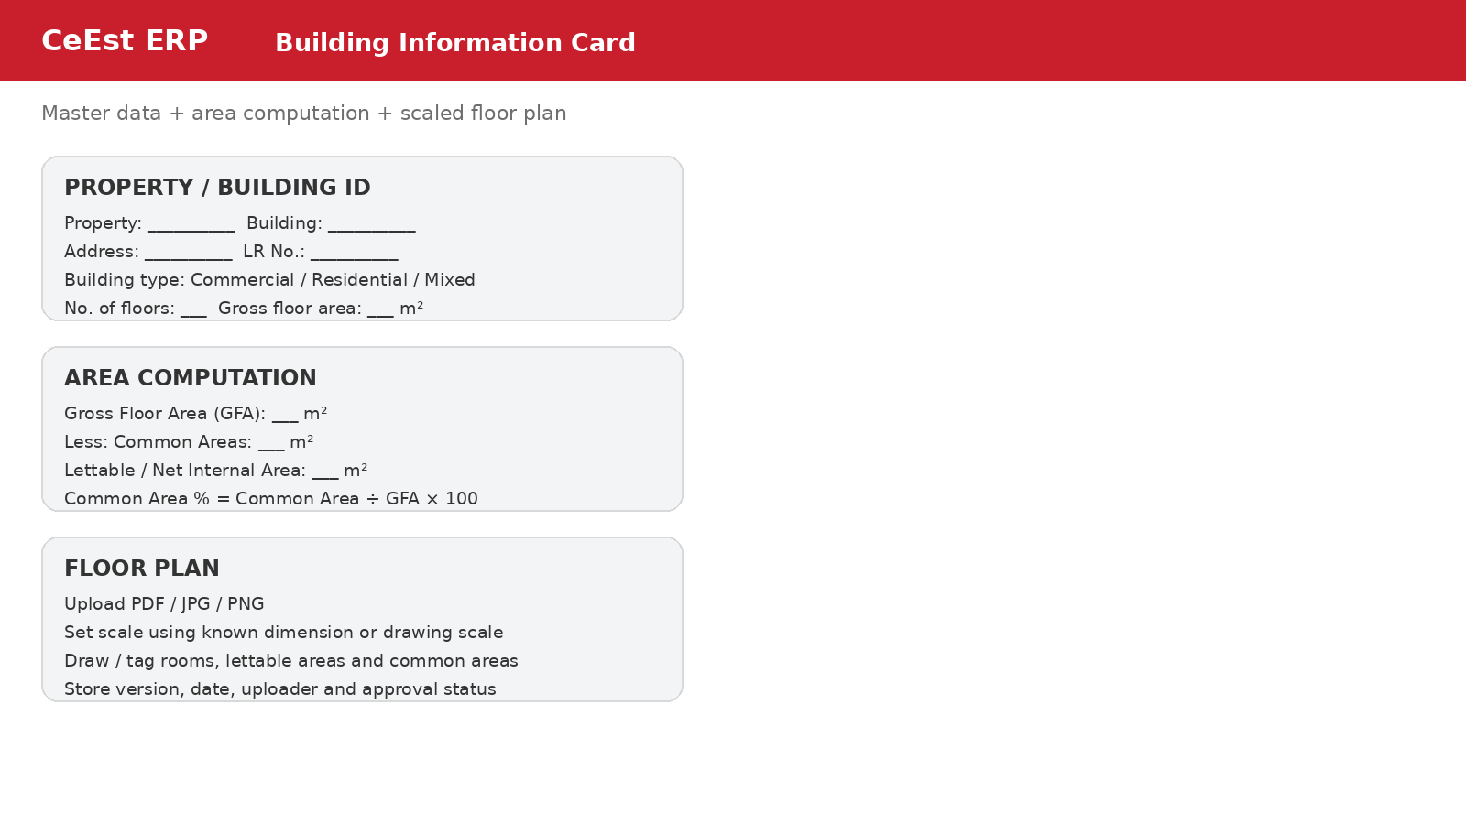

Required fields
Section | Fields / requirements
Identity | Property, building name/code, address, LR number, property type, client/landlord, use
Physical | No. of floors, basement floors, roof type, year built, GFA, NIA/lettable area, occupancy
Areas | Floor-by-floor gross area, common areas, lettable areas, service/core areas, parking/external areas
Plan | Upload PDF/JPG/PNG floor plan, scale, version, date, author, approval, plan number
Documents | Approvals, completion documents, warranties, manuals, photographs
Operations | Operating hours, emergency contacts, access arrangements, critical areas

Area computation logic
The system should calculate areas rather than rely only on manually entered totals.
Metric | Formula / logic
Gross Floor Area (GFA) | Sum of gross measured floor areas for all applicable floors
Common Area | Sum of non-exclusive/shared areas: lobbies, corridors, stairs, lifts, shared toilets, plant/service areas as configured
Lettable / Net Area | GFA less configured non-lettable/common/service areas
Common Area % | Common Area ÷ GFA × 100
Lettable Area % | Lettable Area ÷ GFA × 100
Occupancy % | Occupied lettable area ÷ total lettable area × 100
The developer should allow the client to configure what counts as common/non-lettable for the property. This is important because different properties and leases can use different area conventions.

Scaled floor plans
• Allow upload of PDF, JPG and PNG floor plans.
• Allow the user to set a drawing scale using a known dimension (for example, a 10 m wall) or a drawing scale.
• Allow drawing/tagging of polygons for rooms, lettable areas, common areas and service areas.
• Calculate tagged areas from the calibrated plan where feasible.
• Store plan version, date, uploader, approval status and superseded versions.
• Link units/areas on the plan to the ERP unit register and asset locations.

4. Asset Information Card
Every material building asset should have a unique digital record and remain linked to its property, building, floor and exact location.
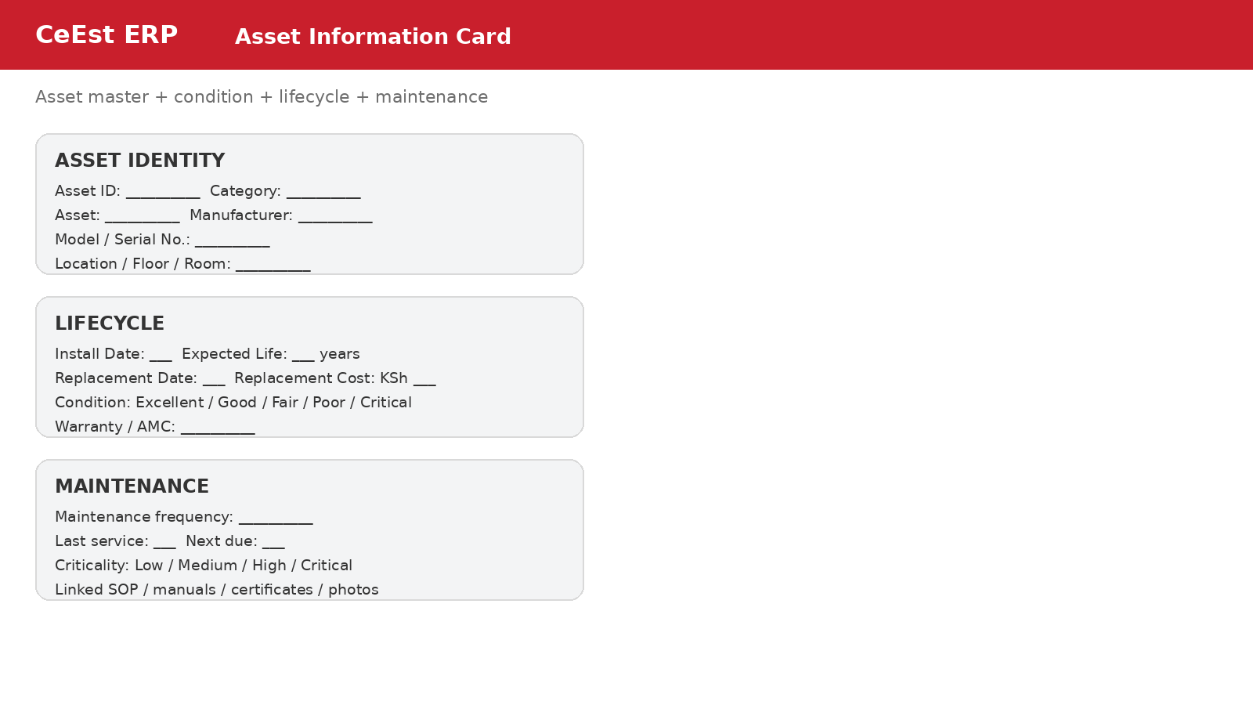
Field group | Minimum fields
Identity | Asset ID, asset class, category, description, manufacturer, model, serial number
Location | Property, building, floor, area/room, GPS where appropriate
Financial | Acquisition/installed cost, replacement cost, funding source, depreciation reference if required
Lifecycle | Installation date, commissioning date, expected useful life, estimated replacement date
Condition | Condition grade, last condition assessment, assessor, defect notes
Maintenance | PM frequency, last service, next due date, maintenance procedure/SOP
Commercial | Warranty, AMC/contract, provider, contract reference, expiry
Evidence | Photos, manuals, certificates, drawings, warranties, test reports
Criticality | Low / Medium / High / Critical; business impact if unavailable

5. Asset Lifecycle Management in the ERP
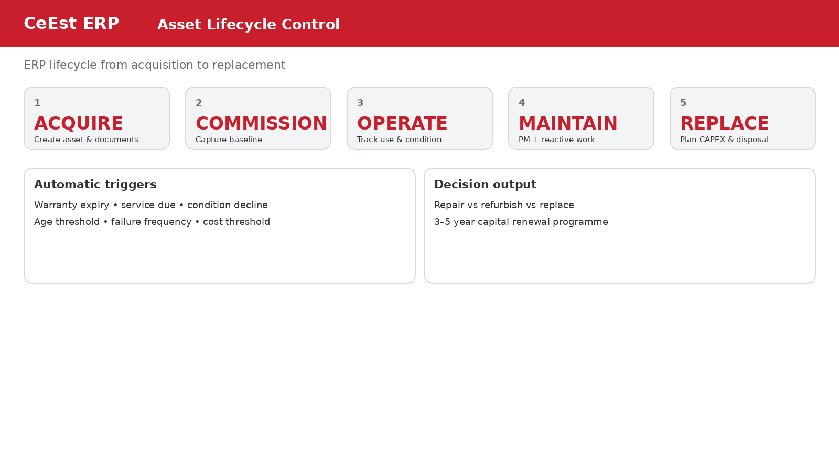
The ERP should manage the full asset lifecycle and create decision triggers automatically.
Lifecycle stage | ERP functions
Acquire | Asset creation, cost, vendor, documents, purchase reference
Commission | Baseline condition, location, warranty, commissioning certificate, initial readings
Operate | Usage/readings where applicable, condition inspections, incidents
Maintain | Preventive schedules, work orders, parts/labour, service history
Assess | Condition score, failure frequency, repair cost trend, criticality
Optimise | Repair/refurbish/replace analysis; energy and efficiency opportunities
Renew | CAPEX proposal, budget, approval, project/work order
Dispose | Disposal approval, handover, financial record and archive
Automatic triggers should include warranty expiry, service due dates, condition deterioration, repeated failures, age thresholds, cumulative repair-cost thresholds and planned replacement dates.

6. FM Plan for Any Selected Property + Performance Against Plan
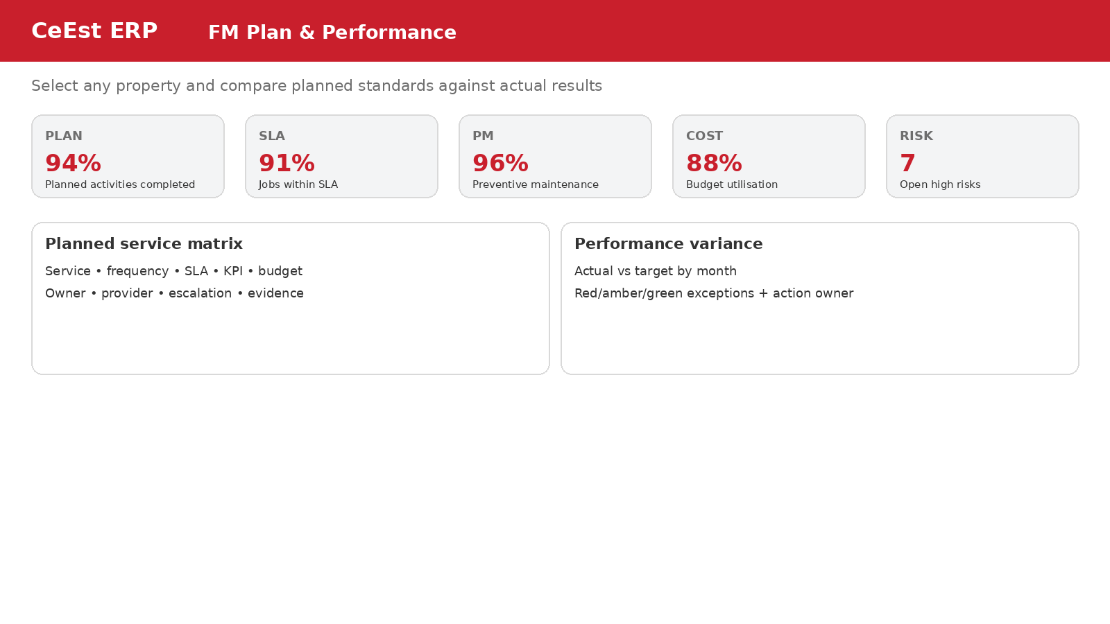
The ERP should allow the FM manager to create one Strategic/Operational FM Plan per property and then automatically compare actual performance against the plan.
FM Plan component | Required system behaviour
Service standard | Define service, scope, frequency, SLA, KPI, responsible party and evidence
Asset maintenance plan | Link assets to PM schedules, tasks, frequencies and service providers
Inspection plan | Define inspection type, frequency, checklist, responsible person and due date
Budget plan | Allocate annual/monthly budget by property, service and cost centre
Compliance plan | List obligations, certificates, due dates, responsible owner and evidence
Risk plan | Identify risks, controls, mitigation actions and due dates
Improvement plan | Record savings, projects, CAPEX and service improvement initiatives

Performance report logic
• Select property + reporting period.
• Pull the approved FM plan for that property.
• Compare planned activity/target against actual ERP transactions.
• Calculate variance and performance percentage.
• Highlight exceptions in red/amber/green.
• Show action owner and due date for every material exception.
• Generate monthly, quarterly and annual PDF/Excel-ready reports.

7. Ticket / Work Order Creation ERP Card
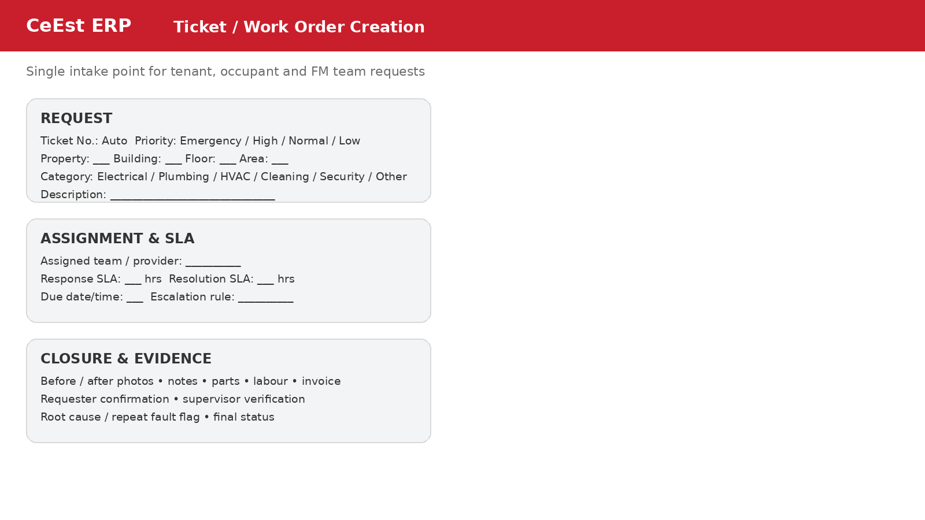
Field | Requirement
Ticket number | Auto-generated unique reference
Source | Tenant, client, caretaker, FM officer, inspection, system-generated PM
Location | Property → Building → Floor → Area/Unit
Asset | Optional/required where fault relates to an asset
Category | Configurable service categories
Priority | Emergency, High, Normal, Low
SLA | Response and resolution targets inherited from service/contract
Assignment | Internal team or service provider
Evidence | Photos, video where supported, quotations, notes, parts
Cost | Labour, materials, contractor, approved cost, invoice/payment link
Closure | Resolution, root cause, requester confirmation, supervisor verification
Analytics | Repeat fault, downtime, SLA breach, first-time resolution

8. Service Provider Creation ERP Card
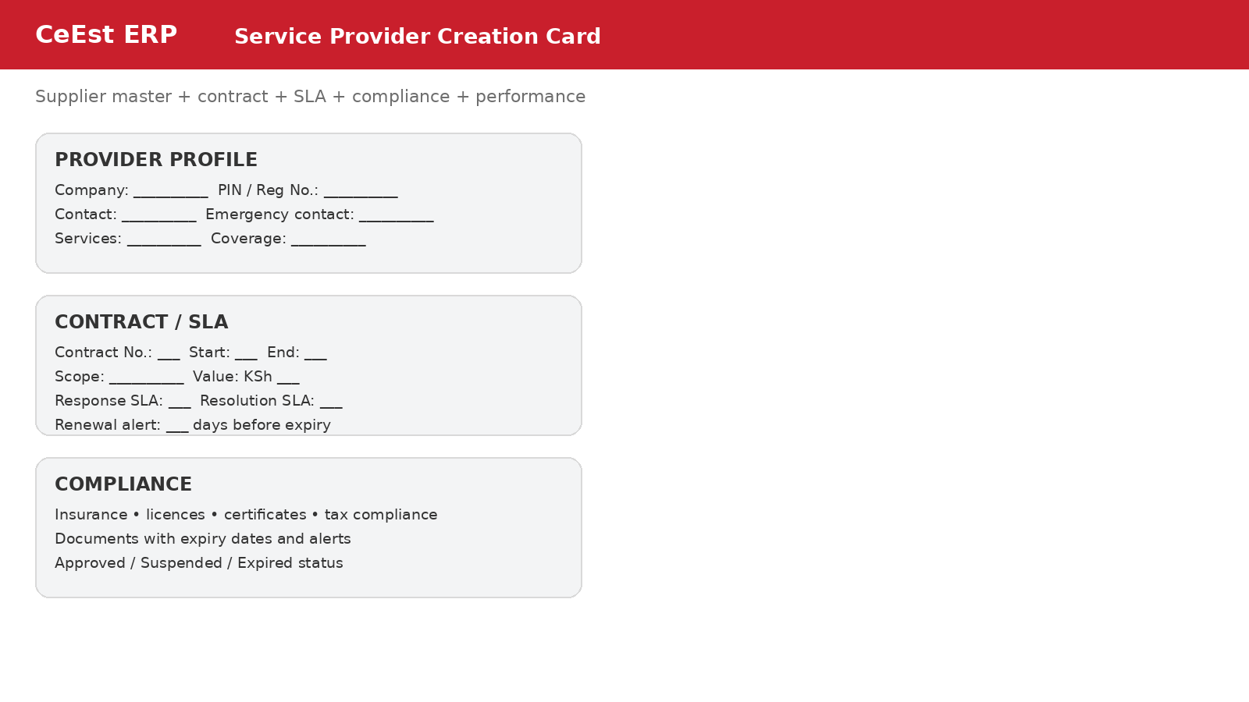
Module | Fields
Company profile | Name, registration, PIN, contacts, address, emergency contact
Service profile | Service categories, geographic coverage, operating hours
Contract | Contract number, scope, value, start/end, renewal, payment terms
SLA | Response, resolution, uptime/quality standards, escalation
Compliance | Insurance, licences, tax documents, certifications, expiry dates
Commercial | Rates, approved rates, quotations, purchase orders, invoices
Performance | KPIs, score, complaints, repeat faults, SLA breaches
Status | Approved, probation, suspended, expired, blacklisted (with authorisation)

9. Service Provider Performance Report Template
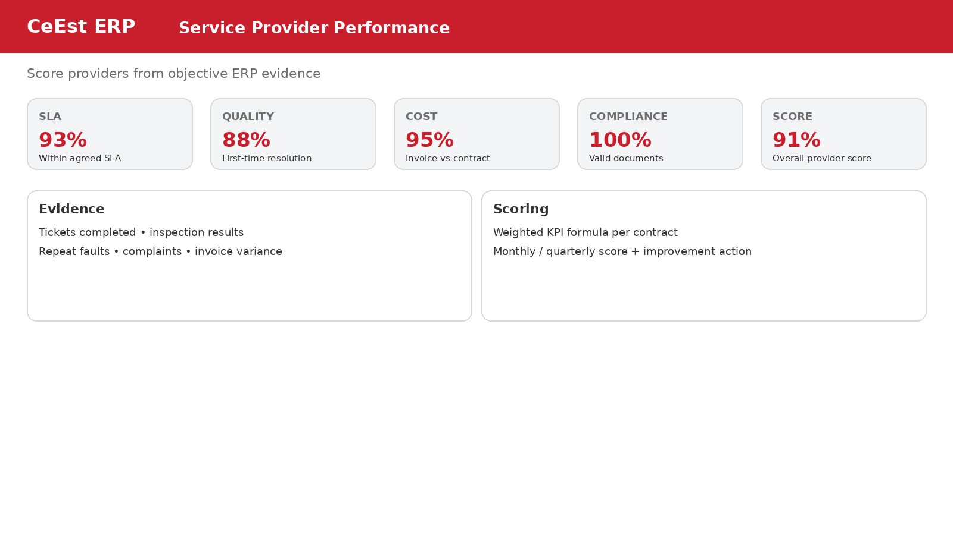
KPI | Suggested weight | ERP evidence
SLA achievement | 20% | Tickets completed within response/resolution SLA
Quality / first-time resolution | 20% | Rework, repeat faults, supervisor verification
Response performance | 10% | Time from ticket creation to attendance
Cost compliance | 15% | Approved rates, quotation/PO/invoice variance
Compliance | 15% | Valid insurance, licences and required certificates
Customer satisfaction | 10% | Requester/client ratings and complaints
Reporting / documentation | 10% | Service reports, photos and closure evidence
Overall Provider Score = Σ(KPI score × KPI weight). The weights must be configurable by contract/service.

10. FM Budgeting + Budget/Cost Report
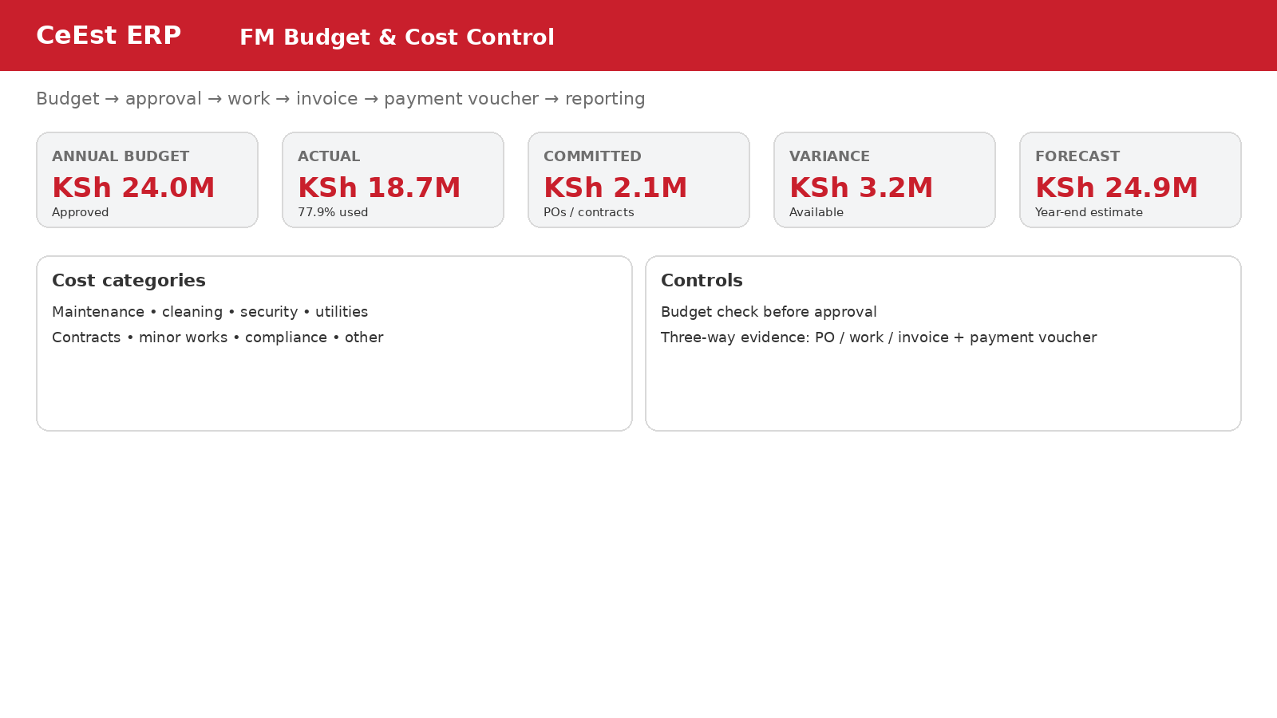
FM budgeting must be integrated with approvals, procurement, work orders, invoices and payment vouchers so that the system controls expenditure rather than merely recording it.
Control | Requirement
Budget structure | Property → service → cost category → period
Commitment | Reserve/track approved PO, contract or work before invoice
Approval | Configurable approval matrix by amount and category
Cost capture | Link actual cost to work order/service/provider/property
Invoice control | Match invoice to approved work/PO/contract and supporting evidence
Payment voucher | Create/link payment voucher and payment status
Forecast | Actual + committed + expected remaining spend
Reporting | Budget, actual, committed, variance, forecast and cost/m²

Core cost reports
• FM Budget vs Actual by property.
• Budget vs Actual by service category.
• Maintenance cost by asset.
• Service provider spend and variance.
• Utility cost and consumption trends.
• Cost per m² and cost per occupied unit where applicable.
• Monthly and annual FM expenditure dashboard.

11. Flagging & Risk Report
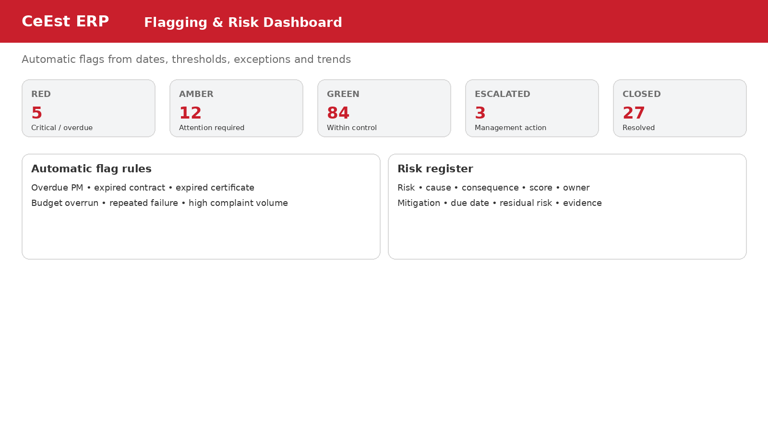
The ERP should contain a rule-based flag engine. Flags should be generated automatically from dates, thresholds, exceptions and trends.
Trigger | Flag example
Date | PM overdue; certificate expires in 30 days; contract expires in 60 days
Cost | Actual spend exceeds budget threshold; repair cost exceeds configured asset threshold
Service | SLA breach; repeated ticket; high complaint volume
Asset | Critical asset unavailable; condition falls below threshold
Compliance | Mandatory inspection/certificate overdue
Risk | Risk score above tolerance or mitigation action overdue

Risk report fields
• Risk ID, property, building/asset, description, cause, consequence, likelihood, impact, inherent score, controls, mitigation, owner, due date, residual score, status, evidence.

12. Compliance Report
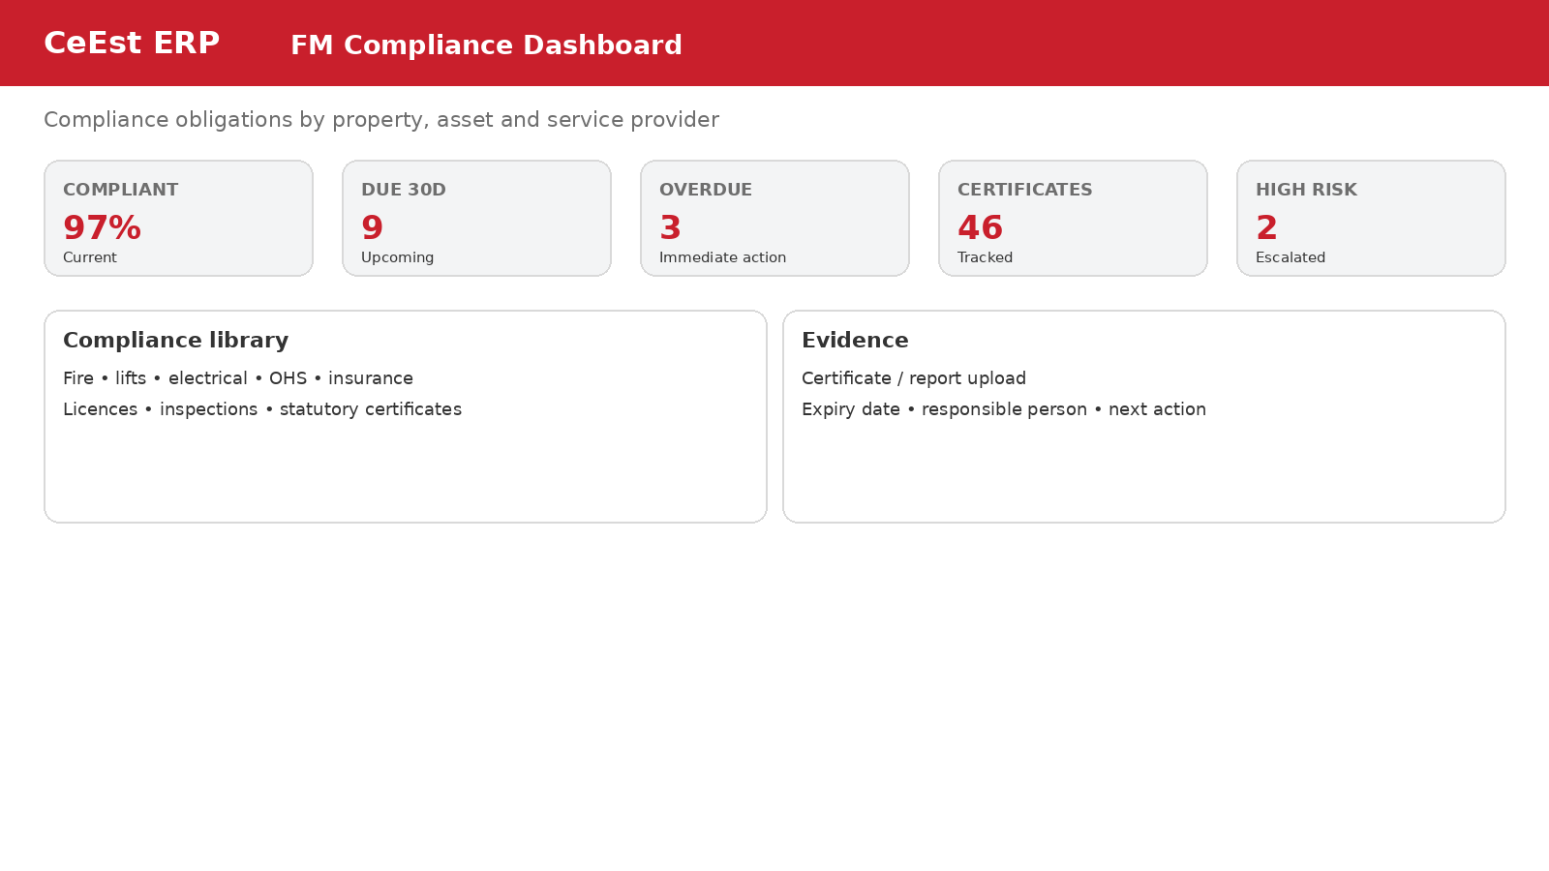
Compliance area | ERP requirement
Fire | Equipment register, inspections, certificates, expiry alerts, defects
Lifts | Service records, inspections/certificates, defects, provider
Electrical | Inspections, test certificates, defects, corrective actions
OHS | Inspections, incidents, corrective actions, training/evidence
Insurance | Policy, asset/property coverage, expiry, renewal action
Service providers | Insurance/licences/certificates and expiry monitoring
Other statutory | Configurable obligation library by property type/jurisdiction
Compliance status should be automatically calculated as Compliant, Due Soon, Overdue or Not Applicable, with evidence linked to each item.

13. FM KPI Engine – How CeEst Should Generate KPIs
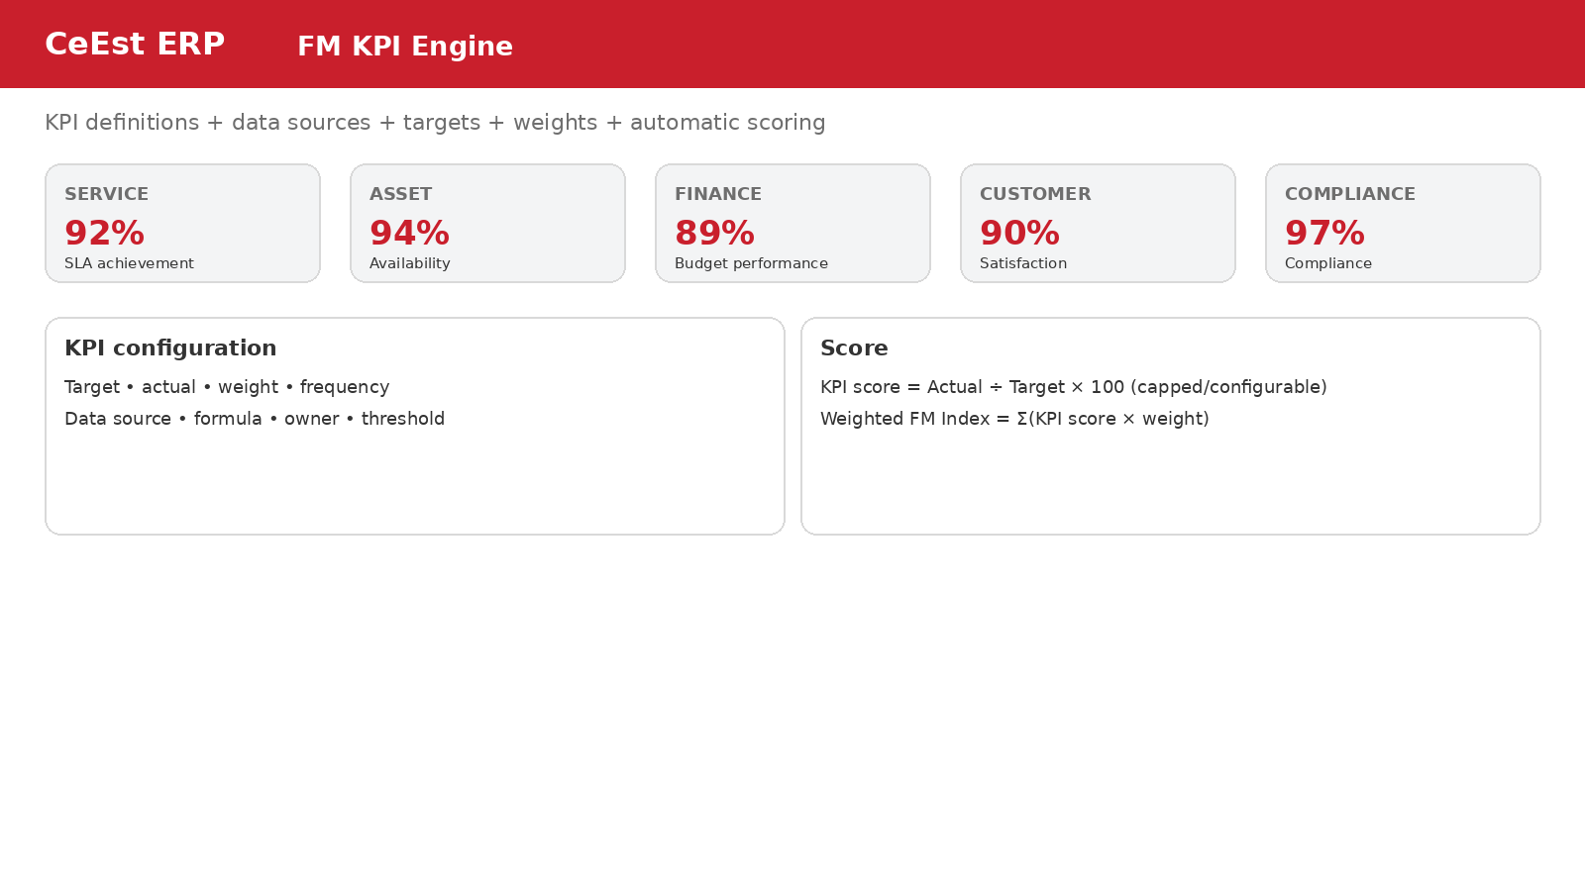
KPIs should be generated from live ERP transactions, not manually typed into reports. Each KPI should have a definition, formula, target, frequency, weight, owner, data source and RAG threshold.
KPI group | Examples | Primary data source
Service | SLA %, response time, resolution time, first-time fix | Tickets / work orders
Maintenance | PM compliance %, overdue PM, repeat faults | PM schedules / work orders
Assets | Availability, downtime, condition, failure frequency | Asset register / incidents
Finance | Budget variance, cost/m², utility cost, forecast | Budget / invoices / vouchers
Compliance | Compliance %, overdue obligations | Compliance register
Providers | Provider score, SLA, cost, quality | Provider + tickets + invoices
Customer | Satisfaction, complaints, closure confirmation | Portal / tickets
Sustainability | Energy, water, waste, intensity | Utility readings / bills

KPI calculation architecture
For each KPI: Data Source → Formula → Actual → Target → Variance → Score → Weight → RAG status. The system should permit different formulas and weights by property type or client contract.
Example: PM Compliance % = completed preventive maintenance tasks on/before due date ÷ scheduled PM tasks due × 100.
Example: SLA Achievement % = tickets completed within contractual SLA ÷ tickets due in period × 100.
Example: Weighted FM Index = Σ(KPI score × KPI weight), with configurable caps/floors and RAG thresholds.

14. FM Manager Dashboard
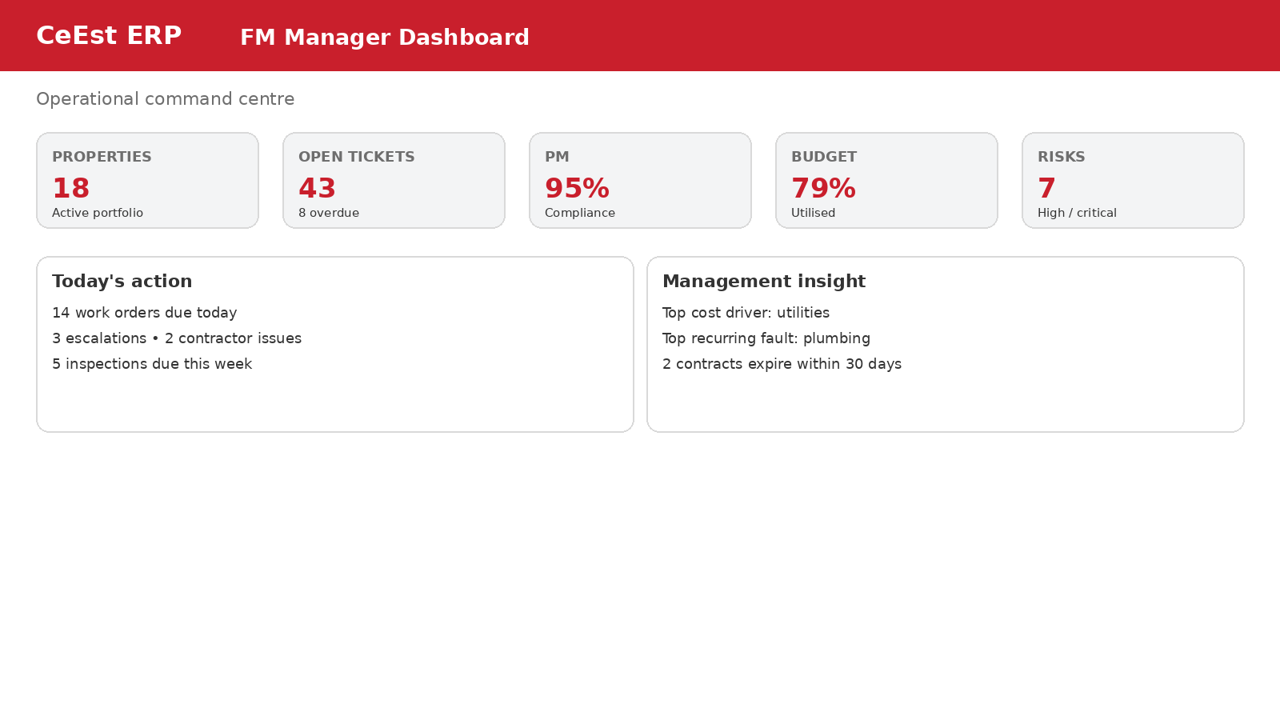
The manager dashboard is an operational command centre. It should answer: What needs attention today? What is deteriorating? What is costing more? Which providers or assets are underperforming?
• Portfolio summary: properties, buildings, assets and active service contracts.
• Today's work orders and overdue escalations.
• Preventive maintenance compliance.
• Critical asset downtime and condition.
• Budget utilisation and forecast.
• High/critical risks and overdue mitigation.
• Compliance due/overdue.
• Contracts and service providers approaching expiry.
• Top recurring faults and cost drivers.
• Management action list.

15. Client FM Dashboard
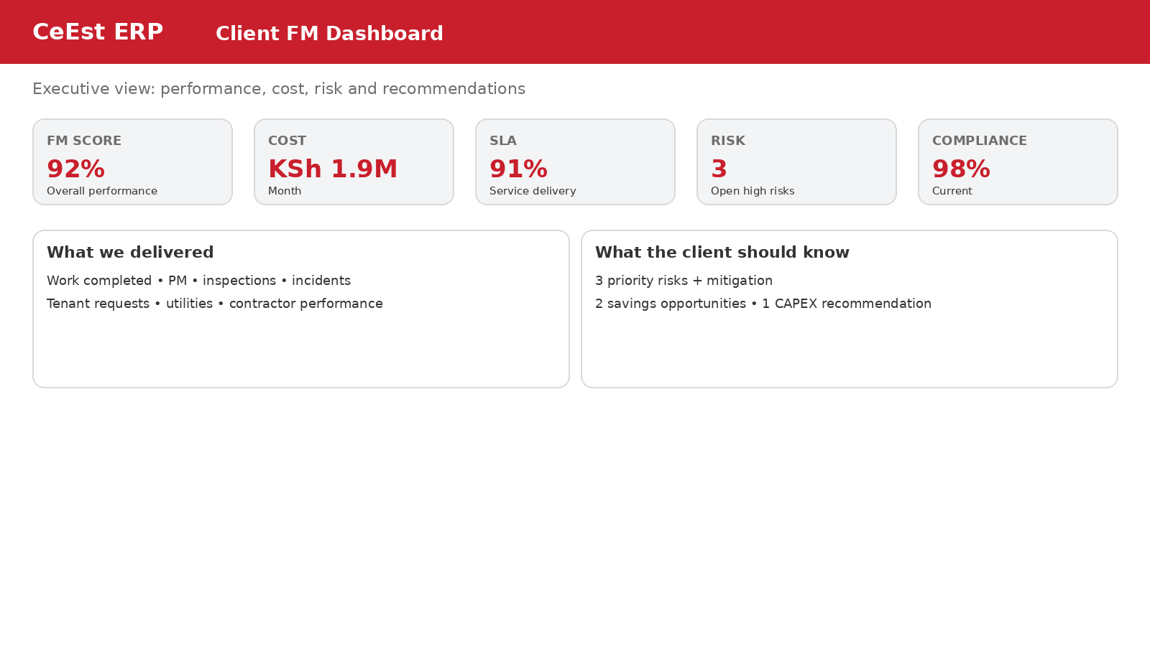
The client dashboard should be simpler than the manager dashboard. It should communicate outcomes, exceptions, cost and recommendations rather than internal task detail.
Client view | What it should show
FM Score | Overall weighted FM performance index
Service | SLA achievement, requests, complaints, major incidents
Cost | Monthly spend, budget utilisation, variance and forecast
Assets | Critical assets, downtime and lifecycle alerts
Compliance | Current compliance and material exceptions
Risk | Top risks, mitigation status and escalation
Utilities | Consumption/cost trends and notable variances
Provider | Overall provider performance and problem areas
Recommendations | CeEst's priority actions, savings and CAPEX recommendations

16. Assessment of the 24-Module CeEst FM Architecture
Based on the FM/ERP requirements developed so far, the 24-module architecture is the correct target structure. The important next step is to connect the modules so that information flows automatically between them.
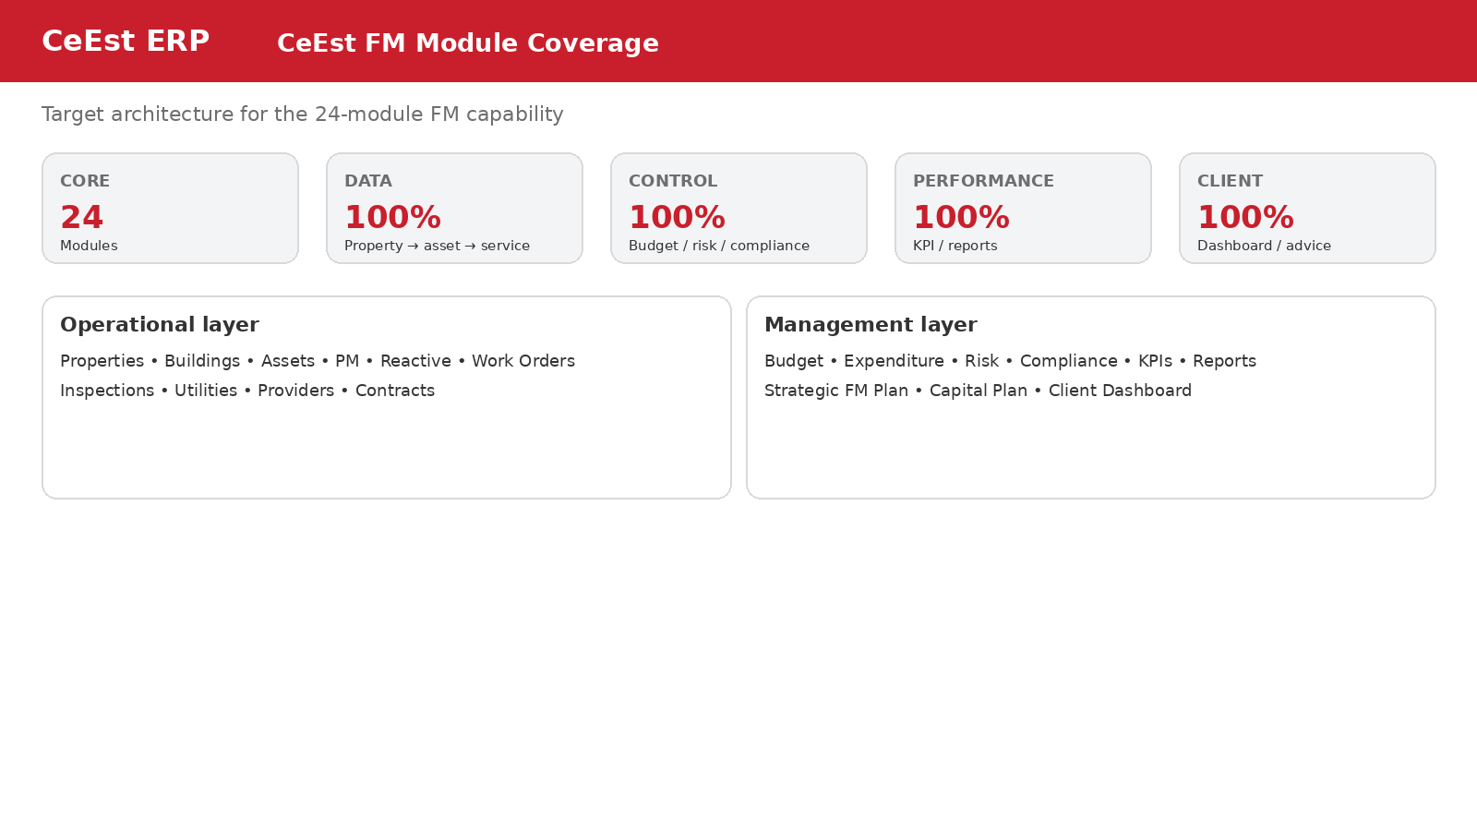
# | Module | Coverage / next improvement
1 | FM Dashboard | Specified; enhance with live KPI/RAG/action widgets
2 | Properties | Already a core foundation; ensure FM hierarchy linkage
3 | Buildings & Areas | Enhance with area computation and scaled floor plans
4 | Assets | Specified; strengthen unique asset master and evidence
5 | Asset Condition | Add formal condition scoring and trend history
6 | Preventive Maintenance | Build recurring schedules, checklists and auto-generation
7 | Reactive Maintenance | Link faults to tickets, assets, cost and root cause
8 | Work Orders / Helpdesk | Build/strengthen unified ticket lifecycle and SLA engine
9 | Inspections | Standardise checklists, evidence, scoring and actions
10 | Compliance | Build expiry/obligation register and automated flags
11 | Utilities | Integrate bills/readings, consumption and cost analytics
12 | Service Providers | Build provider master, contracts, compliance and scorecards
13 | Contracts & SLAs | Link scope, rates, SLA, renewal and performance
14 | Procurement | Connect quotations, approvals, POs and service requests
15 | FM Budget | Build annual/monthly budget and commitment control
16 | Expenditure / Payment Vouchers | Existing requirement; integrate with FM cost transactions
17 | Incidents & Risk | Build risk register, scoring, mitigation and escalation
18 | Projects / Minor Works | Link scope, approvals, budget, progress and close-out
19 | Tenant / Occupant Requests | Link portal requests directly into FM ticketing
20 | KPIs | Build configurable KPI engine from live transactions
21 | Reports | Create scheduled report templates from system data
22 | Client Dashboard | Build executive view with performance and recommendations
23 | Strategic FM Plan | Add property-level service standards, targets and improvement plan
24 | Asset Lifecycle / Capital Plan | Add renewal forecasting and 3–5 year CAPEX planning

17. Required ERP Data Flow
The developer should implement the following relationship so that users do not repeatedly enter the same information:
PROPERTY
↓
BUILDING / FLOOR / AREA
↓
ASSET / SERVICE / CONTRACT
↓
PLAN / PM SCHEDULE / COMPLIANCE OBLIGATION
↓
TICKET / WORK ORDER / INSPECTION
↓
SERVICE PROVIDER / INTERNAL TEAM
↓
QUOTATION / PO / APPROVAL
↓
WORK + EVIDENCE
↓
INVOICE / PAYMENT VOUCHER
↓
COST + PERFORMANCE DATA
↓
KPI / RISK / COMPLIANCE / BUDGET REPORT
↓
FM MANAGER DASHBOARD
↓
CLIENT DASHBOARD + ADVISORY REPORT

18. Minimum Automation Rules
• Creating a property creates the property FM profile and allows buildings/areas to be configured.
• Creating an asset automatically makes it available for PM, inspections, condition and lifecycle tracking.
• Creating a service contract automatically creates renewal and compliance alerts.
• Creating a PM schedule automatically creates future work orders/tasks.
• Creating a ticket automatically calculates SLA due times from priority/service contract.
• Approving a work request should check budget availability where configured.
• Completing work should capture evidence and actual cost before closure.
• Invoices should be linked to the work/PO/contract and available for payment-voucher processing.
• Overdue PM, SLA breaches, expired compliance documents, budget overruns and high-risk actions should create flags.
• KPIs should update automatically after relevant transactions are posted.
• Monthly FM reports should be generated from the approved plan and actual ERP data.
• Client dashboards should expose approved management information without exposing internal approval controls.

19. User Roles & Permissions
Role | Core permissions
System Administrator | Configuration, master data, roles, integrations, audit logs
Executive / Client Manager | Portfolio dashboards, strategic reports, approvals as authorised
FM Manager | Plans, assets, PM, tickets, providers, budgets, KPIs, reports
FM / Operations Officer | Tickets, inspections, work orders, asset updates, evidence
Field Officer / Caretaker | Mobile inspections, tickets, readings, photos, completion updates
Procurement / Finance | Quotes, POs, invoices, budgets, payment vouchers as authorised
Service Provider | Assigned jobs, service reports, evidence, invoice submissions
Client / Landlord | Read-only approved dashboards, reports, recommendations
Tenant / Occupant | Requests, ticket tracking, confirmations and notifications
Auditor / Read Only | Reports, audit trail and evidence without editing

20. Final Developer Priorities
The next development phase should prioritise the following in order:
Priority | Build item | Reason
1 | Property → Building → Area → Asset hierarchy | Everything else depends on accurate property master data
2 | Building area + floor plan module | Creates reliable space/area information
3 | Asset master + lifecycle | Creates the FM asset backbone
4 | PM + ticket/work-order engine | Drives daily FM operations
5 | Service provider + contract/SLA engine | Controls outsourced service delivery
6 | Budget + expenditure + payment-voucher integration | Controls FM cost
7 | Compliance + risk + flag engine | Moves CeEst to proactive risk management
8 | KPI engine + FM plan performance | Converts operations into management information
9 | Manager dashboard | Improves operational control
10 | Client dashboard + advisory reports | Creates the strategic client-facing proposition

21. Definition of Success
The CeEst FM module should be considered successful when a manager can select any property and, from one system, see what the property contains, what services are planned, what has actually happened, what it cost, which assets are deteriorating, which risks or compliance items require attention, how contractors are performing, whether service standards are being achieved, and what CeEst recommends the client should do next.
MANAGE → MONITOR → MEASURE → ADVISE → IMPROVE

